**DAY 02**

**Line separator – fmt.Println()**

**Eg:** fmt.Println("Hello, World!")

**Formater – fmt.Println()**

**Identifiers**

**Key Words: Reseved Words cannot be used as varible_name**

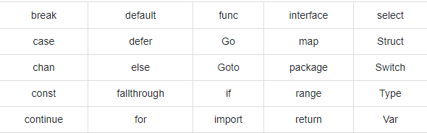

**Data Types:**

**Boolean types**

**Numeric types**

**String types**

**Derived types**

**We need to cover this advance topic**

**Integer**

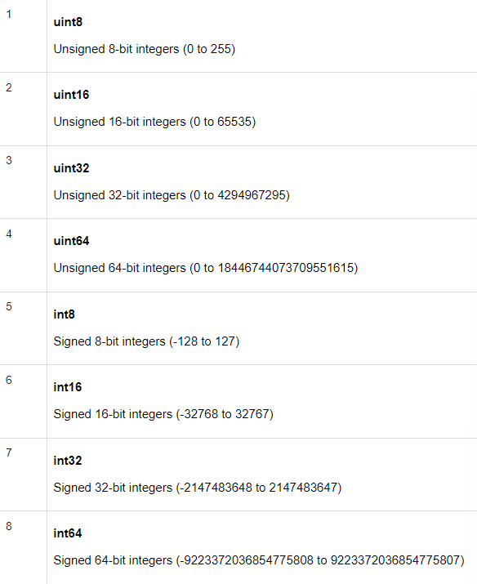

**Floot**

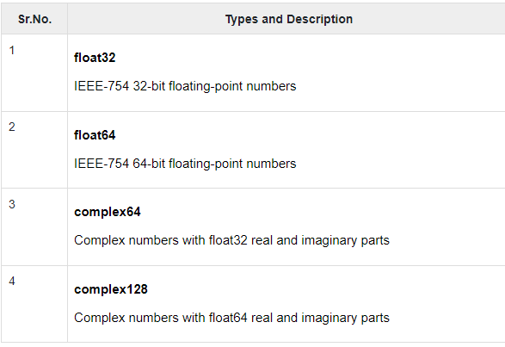

**Complex in the sense: we used have in 10th class a+ib [complex number]**

* **We need to cover** 
  + **Static**
  + **Constant**
  + **Global Variables in clarity**
    - We can define a variable outside the function, these are called Golang Global Variables. These variables can be accessed by any function in the package
  + **Local variable in clarity**
    - Variables that are declared inside a function or a block are termed as Local variables. These are not accessible outside the function or block.
  + **Operators (We need to cover)**
    - +,-,*,%,/

**Dynamic Type Declaration: Creatin of dynamic variables in go**

**A := 10**

1. **Formatting in print**
2. **Formater – fmt.Println()**

**Try and work on**

**Fmt.Printf(“”,value) 🡪 in the Double quotes try and check the difference of each and every conversion.**

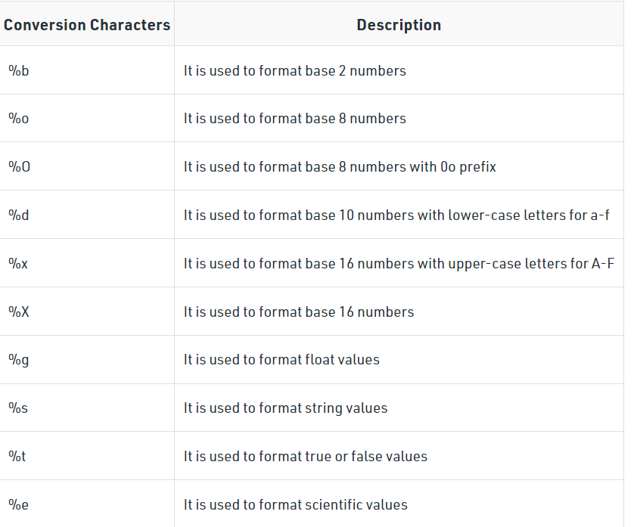

1. **Garbage Collection**

Garbage collection is **a mechanism Go developers use to find memory space that is allocated recently but is no longer needed**, hence the need to deallocate them to create a clean slate so that further allocation can be done on the same space or so that memory can be reused

As Golang developers create programs, they add variables, objects, memories (such as heaps or stacks), or any other object that gets filled up and remains in the memory area and is occupied until the program is live or running. Many of these occupied spaces are never used or, once used, can be safely discarded from the memory. Because memory is still a costly space and must be cleaned periodically to make space for other programs to execute (or for the same program to work efficiently), a cluttered memory with a lot of unused elements can create havoc in the long run.

Read above Matter if any doubts pls ask.